**Membuat Time Zone**

1. Script date.jsp:

|  |
| --- |
| <%@ taglib prefix="c" uri="http://java.sun.com/jsp/jstl/core" %>  <%@ taglib prefix="fmt" uri="http://java.sun.com/jsp/jstl/fmt" %>  <html lang="id">  <head>  <title>Tanggal Sekarang</title>  </head>  <body>  <c:set var="now" value="<%=new java.util.Date()%>" />  <h1>Tanggal dan Waktu Sekarang</h1>  <p>hari dan tanggal saat ini :<time><%= new java.util.Date() %></time><br>  waktu saat ini : <time><fmt:formatDate type="time" value="${now}" /></time></p>  </body>  </html> |

1. 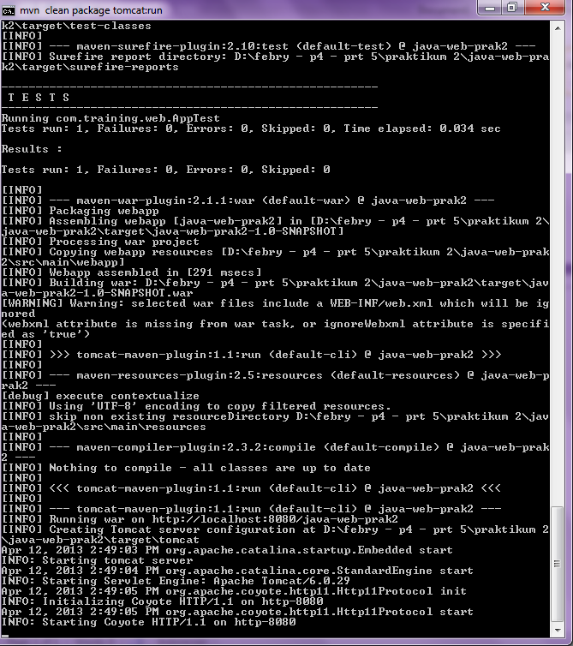Melakukan running file date.jsp mvn tomcat:run
2. Hasil file date.jsp

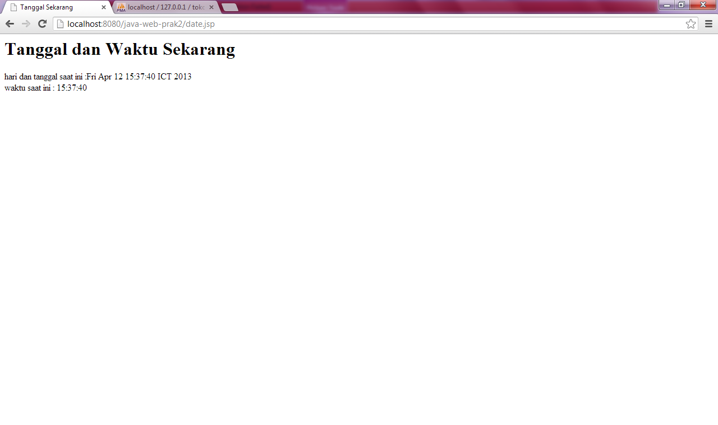

**Membuat Form Data Diri :**

1. Script input.jsp :

|  |
| --- |
| <%@ taglib prefix="c" uri="http://java.sun.com/jsp/jstl/core" %>  <%@ taglib prefix="fmt" uri="http://java.sun.com/jsp/jstl/fmt" %>  <html lang="id">  <head>  <title>Input Data</title>  </head>  <body>  <h1>Input Data</h1>  <form action="hasil.jsp" method="POST">  <table>  <tr>  <td>Nama</td>  <td><input type="text" name="nama" /></td>  </tr>  <tr>  <td>Email</td>  <td><input type="email" name="email" /></td>  </tr>  <tr>  <td>Tanggal Lahir</td>  <td><input type="date" name="tgl" /></td>  </tr>  <tr>  <td>Alamat</td>  <td><textarea cols="20" rows="10" name="alamat"></textarea></td>  </tr>  <tr>  <td colspan="2"><input type="submit" value="Simpan"></td>  </tr>  </table>  </form>  </body>  </html> |

**Script hasil.jsp :**

|  |
| --- |
| <%@ taglib prefix="c"  uri="http://java.sun.com/jsp/jstl/core" %>  <html lang="id">  <head>  <title>Belajar JStl</title>  </head>  <body>  <section>  <h1>HALLO  <c:out value="${param.name}" />  </h1>  </section>  </body>  </html> |

1. Hasil print out :

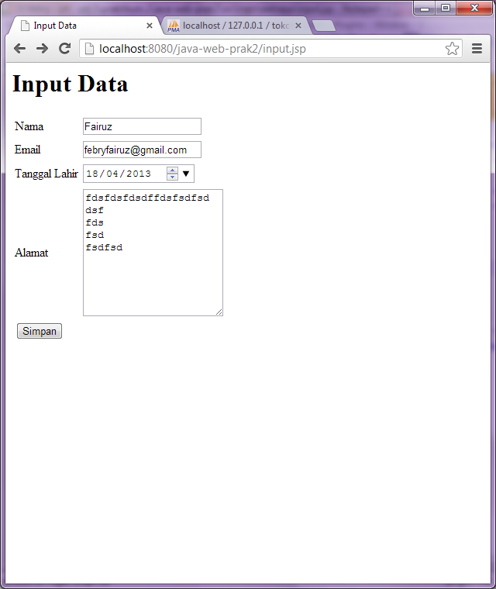

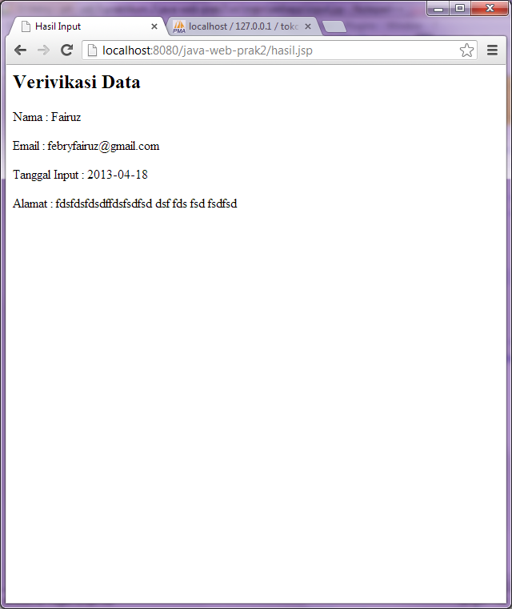

**Menampilkan hasil database dengan JSTL**

1. Script produk.jsp

|  |
| --- |
| <%@ page import="java.io.*,java.util.*,java.sql.*"%>  <%@ taglib uri="http://java.sun.com/jsp/jstl/core" prefix="c"%>  <%@ taglib uri="http://java.sun.com/jsp/jstl/sql" prefix="sql"%>  <html lang="id">  <head>  <title>Menampilkan Query</title>  </head>  <body>  <sql:setDataSource var="snapshot" driver="com.mysql.jdbc.Driver"  url="jdbc:mysql://localhost/tokobagus" user="root" password=""/>    <sql:query dataSource="${snapshot}" var="result">  SELECT * from produk;  </sql:query>  <section>  <h1>Daftar Produk</h1>  <table border="1">  <tr>  <th>Kode</th>  <th>Nama</th>  <th>Harga</th>  <th>Tgl Update</th>  </tr>  <c:forEach var="row" items="${result.rows}">  <tr>  <td><c:out value="${row.kode}"/></td>  <td><c:out value="${row.nama}"/></td>  <td><c:out value="${row.harga}"/></td>  <td><c:out value="${row.terakhir_update}"/></td>  </tr>  </c:forEach>  </table>  </section>  </body>  </html> |

1. Hasil print out :

